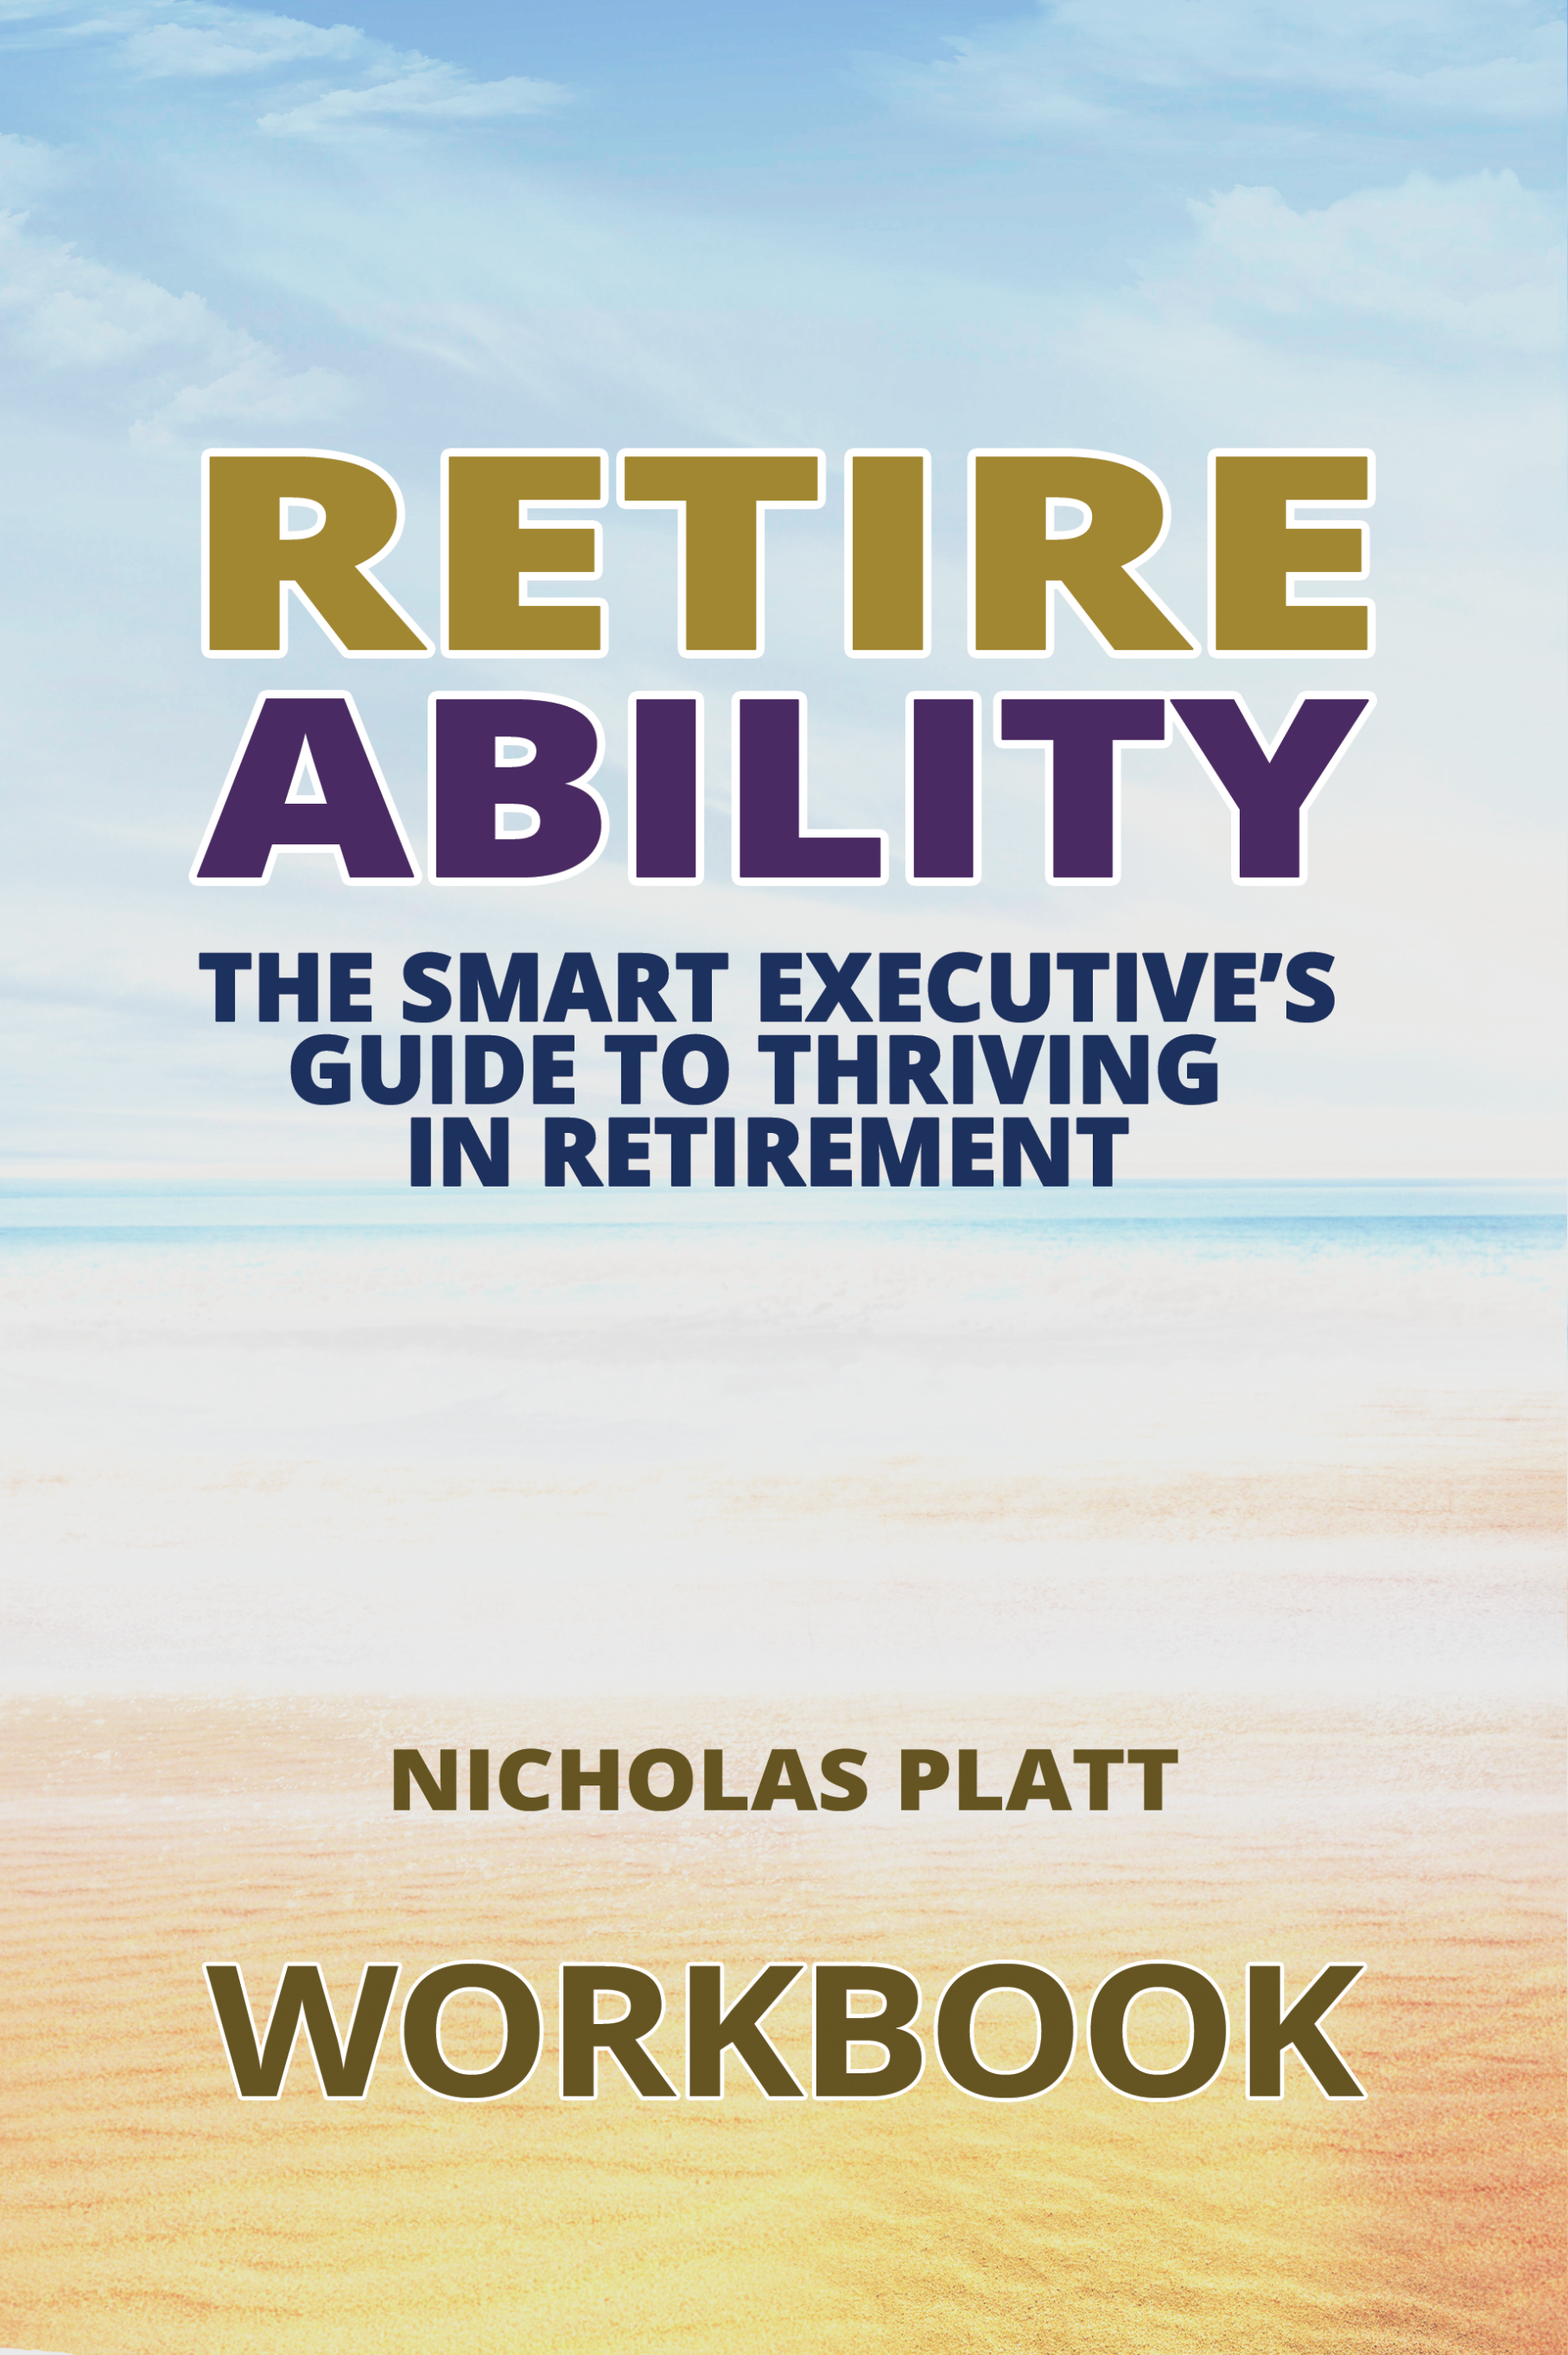
`

How to use this workbook
These exercises are extracted from the book Retireability, written by the Managing Director of Henwood Court Nicholas Platt.
They should be considered after reading each chapter to help with your life and financial retirement planning, to help with your decisions at retirement and life choices into retirement.
They are designed to help you understand ‘what is important to you’, and help you create a transformational action plan to live the life you want to live, what we like to call - living life by design.
If you would like a copy of the expenditure questionnaire to calculate your number this is available as a separate download at www.henwoodcourt/retireability.

Exercise 1: Are you ready to retire?
There is nothing wrong with working hard and putting in long hours, particularly if you are totally engaged and passionate about your work. Indeed, it may have got you to where you are today.
But in doing so it has probably given you the worst preparation for retirement – that is if you actually want to stop working.
Are you obsessed with work above all else? Do you portray workaholic traits? Take this simple test to measure this.
Answer the questions below and score yourself between one and five, jotting down the total when you’ve finished.

The emotional readiness to retire test
- How many hours per week do you typically work?
1 | 2 | 3 | 4 | 5
Below 20 | 20-35 | 35-50 | 50-60 | Above 60

- How many evenings (after 6pm) do you typically work?
1 | 2 | 3 | 4 | 5
None | 0-1 | 1-2 | 2-3 | Above 3

- How many hours do you work on a weekend?
1 | 2 | 3 | 4 | 5
None | 1 | 1-3 | 3-5 | Above 5

- How many evenings do you get home from work, have dinner, and then work again before bed, even if just checking a few s?
1 | 2 | 3 | 4 | 5
None | 1 | 1-2 | 2-3 | Above 3

- How many hours do you work each day when you are meant to be on holiday?
1 | 2 | 3 | 4 | 5
None | 0-1 | 1-2 | 2-3 | Above 3

Score
My score is:__________
More than 21 | Retirement is going to be a big emotional challenge for you given the obsessive, possibly addictive, relationship you have with work, particularly the closer you are to retirement.
16-21 | Retirement will be difficult, although not emotionally impossible.
11-15 | This is a healthy target score in relative terms for executives aged between 30 and 50. The transition into retirement should not be too difficult.
10 or less | Retirement should be a very easy transition for you. This is the target score for an executive within five years of retirement, maybe in a state of pretirement.

It would be bold and wrong to state that if you score more than 21 it will be impossible to successfully transition from work to retirement. Indeed, I have witnessed many workaholic executives go cold turkey and embrace retirement.
But I have also seen this go horribly wrong.
However, I do believe it is fair to generalise that the higher your score the bigger the impact of retirement shock and the harder it will be to successfully transition from executive to retiree.
The average score having done this exercise with many executives is between 16 and 21. If you have scored more than 21, don’t worry, you are not alone.
As you will be aware, a common trait among executives is to work hard and that often means long hours. It goes with the territory and for some it’s a badge they are proud to wear.
The purpose of the above test is to measure where you are now. This will go some way to helping you recognise how obsessed or preoccupied you are with work. It is my view if you cannot measure something then you cannot change or improve it.
Once measured, you may plan how to reduce your score to help you to become more emotionally prepared for retirement (there are techniques for doing this in the next chapter).
If you scored highly in question four, for example, you could bring your score down by simply committing to never working after dinner, and instead do something with that time you’ve freed up for yourself.

Exercise 2: Transformational life plan
It’s time to create your transformational life plan, starting with these questions. Answer these now, but after you have completed the rest of the book you may wish to reconsider your answers and allocate more time to these exercises.
- At what age do you want the option to retire?
- If you had three hours extra each day, and you were forbidden to work, what would you do with this free time?
- Are you ready to take time from your corporation and gift this to yourself? If yes, explain why you are ready. If no, explain why you are not ready.
- What baby steps can you take today to wrestle time from your corporate self? Choose one and create an action plan to make this happen.
Baby step
Action plan
- What is important to you?
- Now put the above in priority order and rate your performance out of ten? If you scored less than ten in each priority, identify your target score and what actions can you take to reach this score? Consider how you score points – make these very specific. Ideally, you should have five or six priorities and no more.
Priority | Rating | Target Score & Actions
- Using a separate sheet of paper, create your own goal timeline, with focused goals (life and financial) over the next three years and your someday goals (beyond three years). Using the example in this chapter as a guide, answer Dan Sullivan’s question:
“If we were having this discussion in the future and we were looking back over the previous years, what has to have happened over the years for you to feel happy about your progress?”
- Now answer George Kinder’s three questions:
- I want you to imagine that you are financially secure, that you have enough money to take care of your needs, now and into the future. The question is: How would you live your life? Would you change anything? Let yourself go. Don’t hold back on your dreams. Describe a life that is complete and that is richly yours.
- You visit your doctor, who tells you that you have only five to ten years left to live. The good part is that you won’t ever feel sick. The bad news is that you will have no notice of the moment of your death. What will you do in the time you have remaining to live? Will you change your life and how will you do it?
- This time, your doctor shocks you with the news that you have only one day left to live. Notice what feelings arise as you confront your very real mortality. Ask yourself this: What did I miss? Who did I not get to be? What did I not get to do?
- Who can you ask to be your accountability coach?
Now you have completed the above, get your diary and put some “life” into it, allocating time to do what is important to you.
Then contact your potential accountability coach, arrange to meet with them and ask them if they are willing to help you.

Exercise 3: Financial planning
- Calculate your “number” – that is the amount you will spend for the rest of your life.
Stage | £ Amount
Now until retirement
Phase One – retirement until age 75/80
Phase Two – from 75/80 to 100
One-off capital expenditure
Total (your number)
Remember to use the spreadsheet for this if you prefer. It’s included in the download.
Having an understanding of this is crucial for planning but futile unless you consider your lifetime inflows, and current and future resources, so that you may then project these forward using cash-flow modelling to demonstrate if you have enough (or maybe too much) money to fund your number.
While I am sure you are able to do basic maths to calculate your total expected future lifetime inflows and then compare this with your number, the calculation and complexity involved is beyond any exercise we can do here. But we would encourage you to consider your existing and future resources, and your personal and financial assumptions, so you may crunch and project these numbers with a suitably qualified financial planner – the outcome from which will drive your financial and retirement strategies.
At the very least you should have an understanding of:
- Your expenditure today and expected into retirement.
- Expected one-off costs in retirement (e.g. holiday home).
- Your income today and projected into retirement.
- Expected one-off windfalls into or at retirement.
- Your expected capital assets into retirement.
- How much capital you need to accumulate for retirement.
- Your pension, savings and investment strategy.
If you do not have an understanding of any of the above financial matters, take some time to consider these before it is too late.

Exercise 4: Retirement considerations
You have a lot to consider at retirement, so work through the checklist below:
- Do you want to retire?
If no, explain why. If yes, why? What do you want to do? What is your purpose? What is on your retirement bucket list? Describe your dream retirement and, importantly, what you do not want to do.
- Should you consider pretirement? What can you do and what do you want to do? Is it doable?
- Can you afford to retire? Have you got too much money or not enough? Explain your answer, and if you don’t know then make it your priority to understand (get advice). If you have too much, think about what you can spend money on to make you and those you love happier, or maybe others’ lives easier. If you do not have enough money, consider how you are going to make retirement work for you? What actions do you need to take?
- Consider your spouse and family when you retire, how it will affect them?
- Have you obtained a list of all your pensions, reviewed their suitability and explored your options for income and commuting a lump sum? Write down what you have done and what you still need to do?
- In relation to pensions, have you investigated:
- Calculating your lifetime allowance?
- Maximising pension funding prior to retirement?
- Funding pensions post-retirement?
Comments
- On leaving your company, have you explored your options (if applicable) relating to:
- Your company car?
- Your private medical insurance?
- Your death-in-service benefit?
- Share options and long-term incentive plans?
- Pension benefits and options?
- Contacted HMRC?
Comments
- Retirement is a good time to review your investment strategy, to consider the purpose of your investment (growth, income, both) and the investment philosophy you wish to engage. In particular understand:
- Your annual income and expenditure.
- What annual investment return (%) you need.
- Your risk profile and downside tolerance.
- The importance of cash within an emergency fund.
- Investments are medium to longer term strategies.
Comments
- Retirement is an opportune time to review your estate plan, in particular consider:
- Making or updating your will.
- Arranging a lasting power of attorney.
- Calculating the estate’s liability to IHT.
- Gifting and its affordability.
- Multi-generational planning.

Comments

Exercise 5: Plan your activities
You only get one shot at retirement, so make it count. The exercises in Chapter Two helped you to understand what is important and to prioritise.
But let’s go back to basics and consider your life now. What activities do you like and what do you dislike?
Like | Dislike
- Next, note the amount of time you are spending on each activity and consider what actions you can take to reduce the time spent doing things you dislike and increase the time spent doing things you do like.
- There is a big difference between “time-filling” activities and “fulfilling” activities. In retirement, leisure activities often replace workplace functions to meet our basic needs. Successful retirees balance their leisure over many different activities and take the opportunity to do new things and not get into a rut. What leisure activities will you do?
- How do/will you maintain a healthy mental and physical condition in retirement? What’s your purpose?
- As you get older, an active social network becomes increasingly important to replace your work tribe. As part of your retirement plan you should consider what groups you wish to be part of. How will you maintain your social network?
- Describe your ideal retirement vision?
- What needs to happen to turn your vision of an ideal retirement into a reality?
- How would you like to be remembered?
- If anything, what do you need to do to be remembered as the person described above?

Keep in touch
We sincerely hope that Retireability and these exercises have helped you with your own retirement planning.
If you would like to speak to a financial planner at Henwood Court regarding your own retirement plans then we would love to hear from you.

Contact details
Henwood Court Financial Planning Ltd
The Cruck Barn
20 Country Park View
Sutton Coldfield
B76 1TE
Telephone +44 (121) 313 1370

Email : info@henwoodcourt.co.uk
Website: www.henwoodcourt.co.uk
Email: info@henwoodcourt.co.uk
Facebook: Henwood Court Financial Planning Ltd
Twitter: Henwood Court – @henwood_Court
Nicholas Platt – @henwoodcourt

Annual expenditure multiplied by the number of years until retirement.
Such as gifts to children, property purchases, holiday homes, mobile homes, cars or other material purchases.
Salary, future pension incomes, inheritances, windfalls from bonuses, property sales (including a possible downsize) or share maturities.

